RIHAM AHAMED ABDUL RAHEEM

HND COMPUTING IDM

DOCUMENTATION

Contents

Introduction 1

Entity-Relationship-Diagram 2

Class Diagram 3

Database Normalization 4

Login Screen 5

Main Screen 7

Patient form 8

Invoice form 8

**List of figure**

Figure 1: Initial Screen 1

Figure 2: HMS Database ER Diagram 2

Figure 3: Class Diagram in HMS 3

Figure 4: Login Screen in HMS 5

Figure 5: User_ID, Password and User_Type 5

Figure 6: Login Screen code 6

Figure 7: Main Screen nurse & Doctor 7

Figure 8: Nurse main screen code 7

Figure 9: Doctor main screen code 7

Figure 10: Invoice form 8

Figure 11: Patient form 8

Figure 12: Invoice code 9

# Introduction

I Choose the IDE is Visual Studio 2015. It has basic features like code editor, debugger, builder, object explorer for every IDE, but goes one step further and provides form design, code completion, data source link, performance definitions and document structure.

During the process of developing the plan for the new Lanka Hospital, all these features were fully utilized to get the most out of IDE and to facilitate my experience during development.

My choice of database engine is SQL Server 2012, provided by Microsoft, which comes with a management studio that allows developers to effectively create, maintain and maintain databases, create tables, links, and a runner that runs SQL queries on tables.

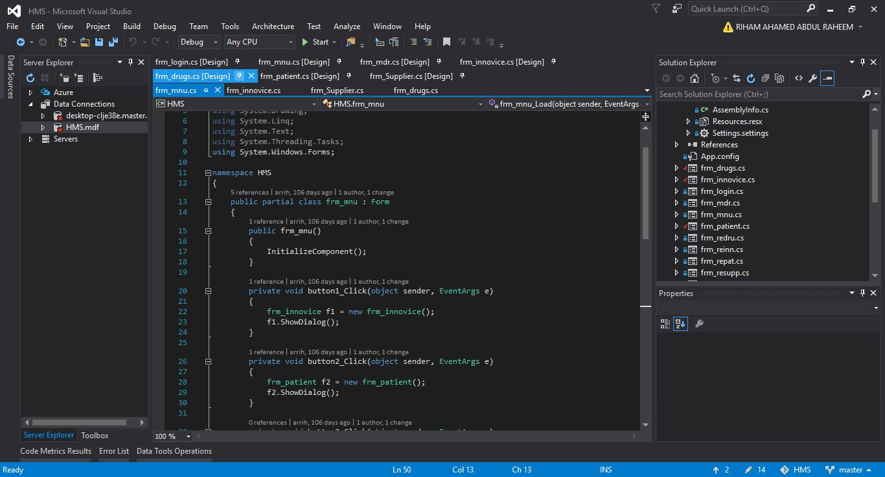

Figure 1: Initial Screen

# Entity-Relationship-Diagram

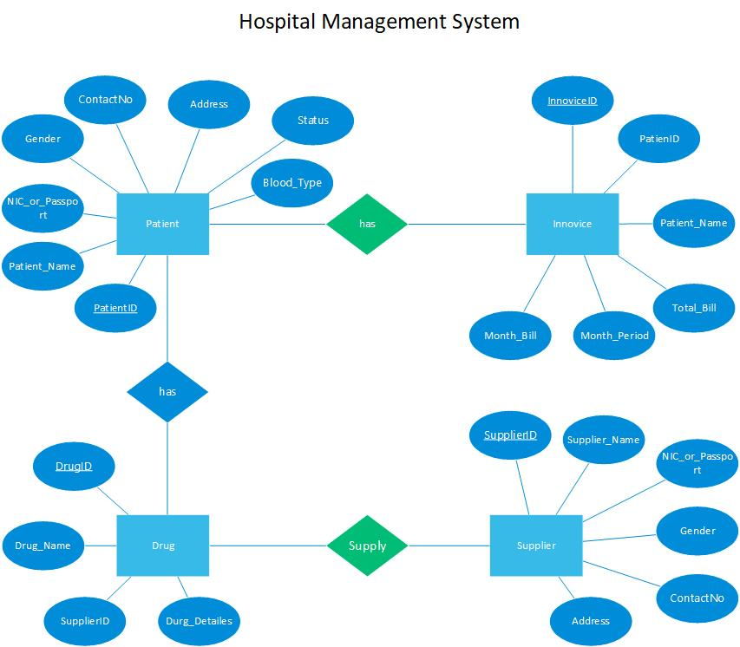

Figure 2: HMS Database ER Diagram

# Class Diagram

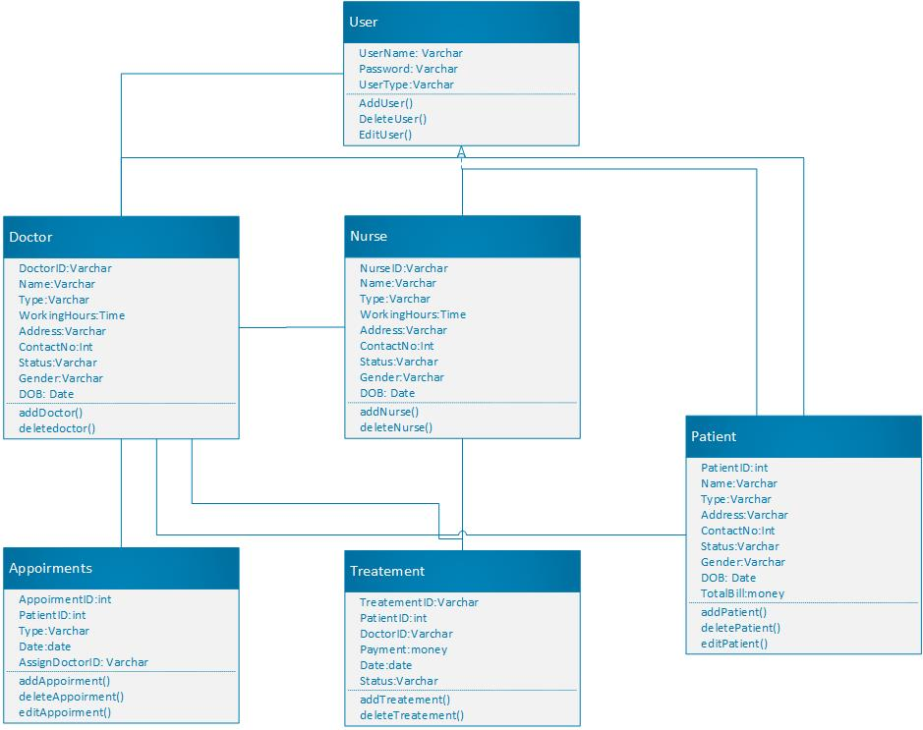

Figure 3: Class Diagram in HMS

# Database Normalization

First Normal Form Test;

1. Ensured that there are only single valued rows and columns
2. All column names have been made unique
3. Ordered in ascending order

Hence New Lanka Database passed the 1NF test.

Second Normal form Test;

1. Database has been ensured and rechecked to see if it’s in the first normal form
2. All data has been checked for partial dependency and those that did, were removed.

Hence New Lanka Database has passed the 2NF test.

Third Normal form test;

1. 2NF test has been passed
2. Database consisted transitive dependencies, so 3NF test failed. In order to pass the test, all the data was checked, transitive dependencies were researched and then eliminated.

After fixes and compromise of some data, 3NF test was passed.

Hence all tables in the database are normalized to 3rd normal form

# Login Screen

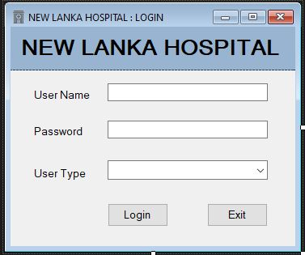

Figure 4: Login Screen in HMS

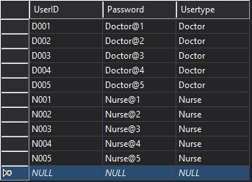Before the main screen is displayed. a login form will be show. You must enter the User Name, Password and select the user type from between Doctor and Nurse. Below the user’s name password and user type are.

Figure 5: User_ID, Password and User_Type

Figure 6: Login Screen code

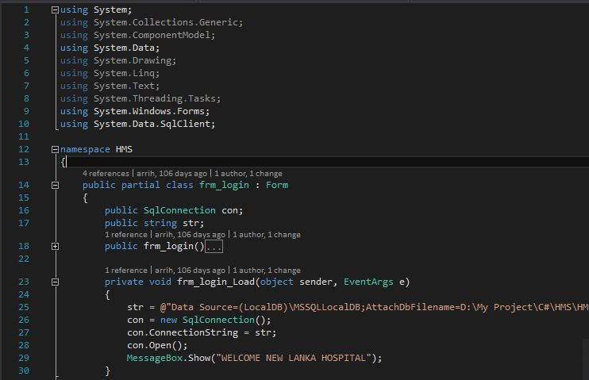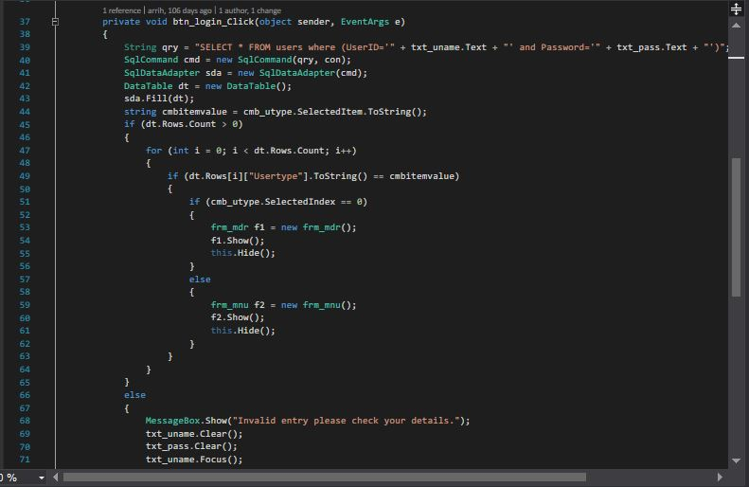

# Main Screen

Figure 7: Main Screen nurse & Doctor

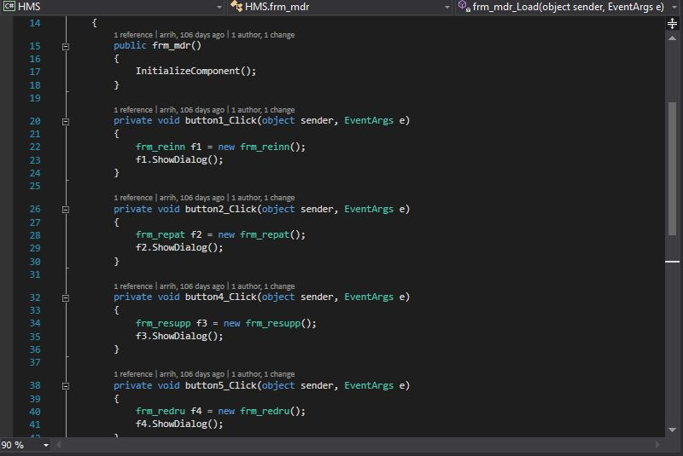

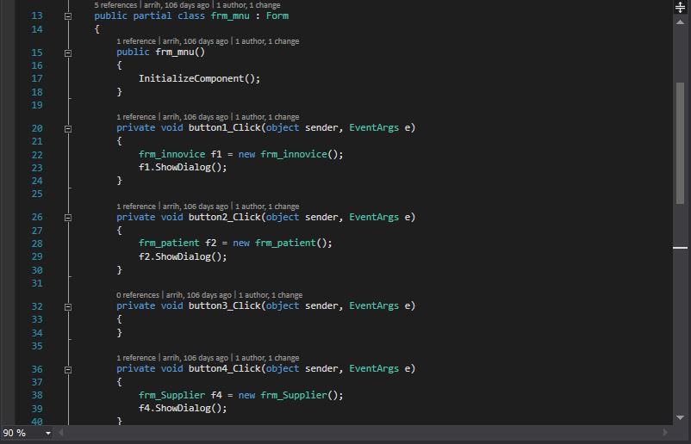

Figure 8: Nurse main screen code

Figure 9: Doctor main screen code

Doctor only see the report but nurse is added, update and delete so sprite main screen.

# Patient form

# Invoice form

Figure 10: Invoice form

Figure 11: Patient form

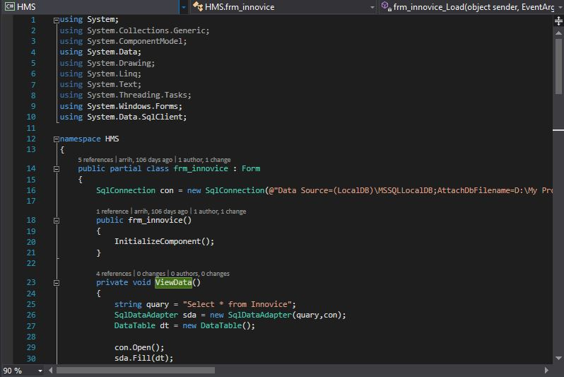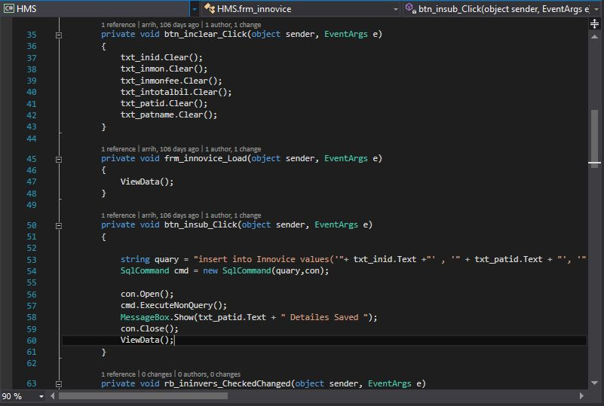

The HMS system was many forms Ex. Patient, Invoice, Supplier and Drug all forms are same for figure10 and figure11 and code also proximity same figure12.

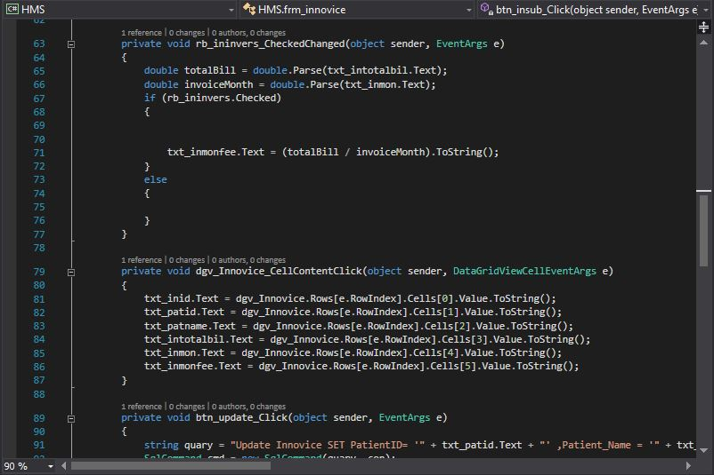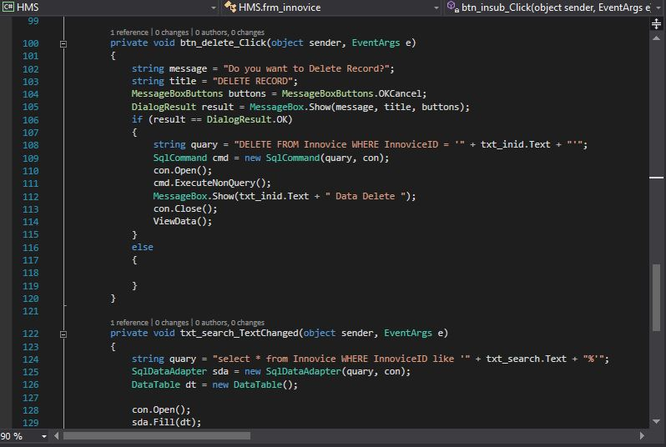

Figure 12: Invoice code